**FACE RECOGNITION ATTENDANCE SYSTEM**

Name:- Tushar Potdar

TABLE OF CONTENTS

|  |  |  |
| --- | --- | --- |
| **S. No** | **TITLE** | **PAGE NUMBER** |
| 1 | INTRODUCTION | 1 |
| 2 | PROBLEM STATEMENT | 2 |
| 3 | OBJECTIVES | 5 |
| 4 | PRODUCT PROTOTYPE | 6 |
| 5 | STEPS IN FACE-RECOGNITION | 7 |
| 6 | FEASIBILITY STUDY | 10 |
| 7 | METHODOLOGY | 17 |
| 8 | RECOGNITION TECHNIQUES | 19 |
| 9 | DISCUSSION | 32 |
| 10 | FUTURE SCOPE | 33 |
| 11 | CONCLUSION | 36 |
| 12 | REFERENCES | 37 |

## 1. INTRODUCTION

**1.1 PROJECT**

Face Recognition Attendance System

### 1.2 INDUSTRY AND TECH

For this particular project, The tech used is **Computer Vision** and the industry domain selected is **Education**.

Computer vision is a field of Artificial intelligence (AI) that enables the computers and systems to derive meaningful information from digital images, videos and other visual inputs and take actions and take actions or make recommendations based on that information. If AI enables computers to think , Computer vision enables them to see, observe and understand.

Computer vision works much the same as human vision, except humans have a head start.Human sight has the advantage of lifetimes of context to train how to tell objects apart, how far away they are, whether they are moving and whether there is something wrong in the image.

Computer vision trains machines to perform these functions, but it has to do it in much less time with cameras, data and algorithms rather than retinas, optic nerves and a visual cortex. Because a system trained to inspect products or watch a production asset can analyze thousands of products or processes a minute, noticing imperceptible defects or issues, it can quickly surpass human capabilities.

Computer vision has many applications in modern day world , like for example:

1. Security systems can leverage the power of computer vision to identify theft or potential danger.
2. Google translate uses computer vision technology which can read text from a picture in one language and translate it to another.
3. Self driving cars like Tesla use computer vision technologies to get data of the road, vehicles on that road and pedestrians to guide behavior of the car.

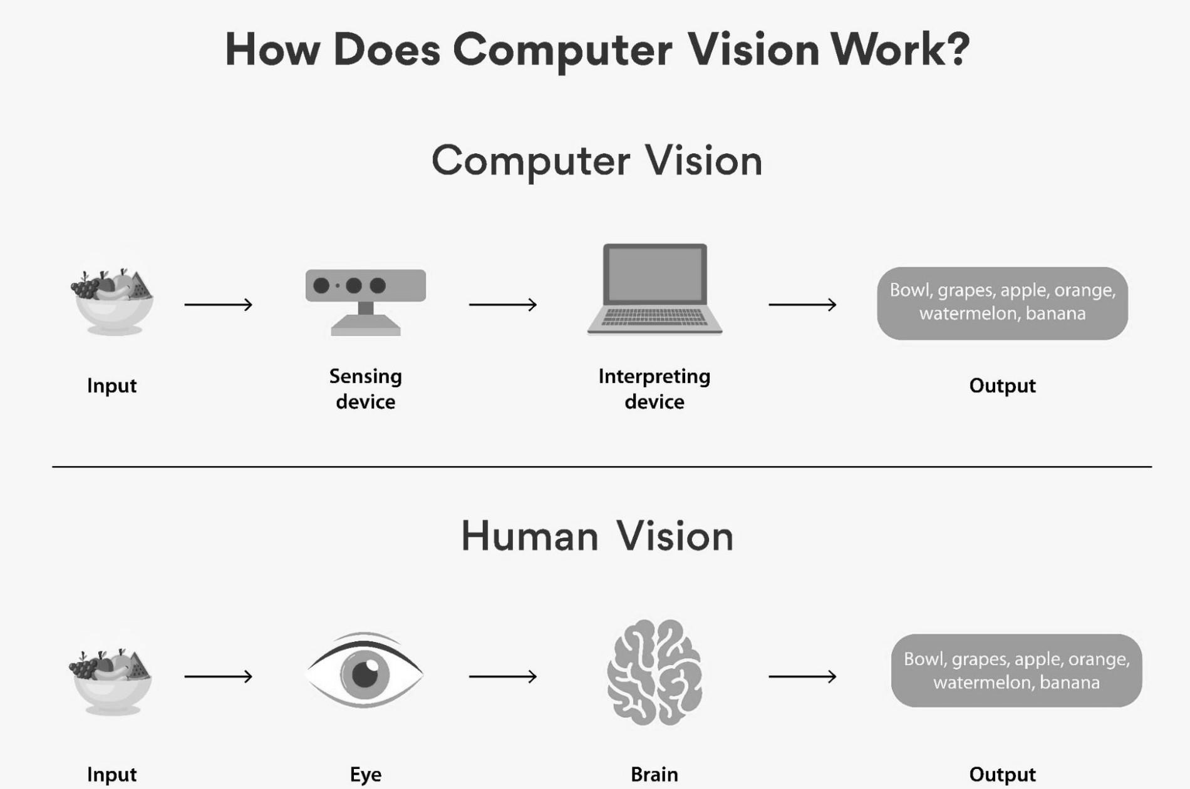

Fig 1. Google : How computer vision work

Future scope of computer vision industry by million in US Dollars :

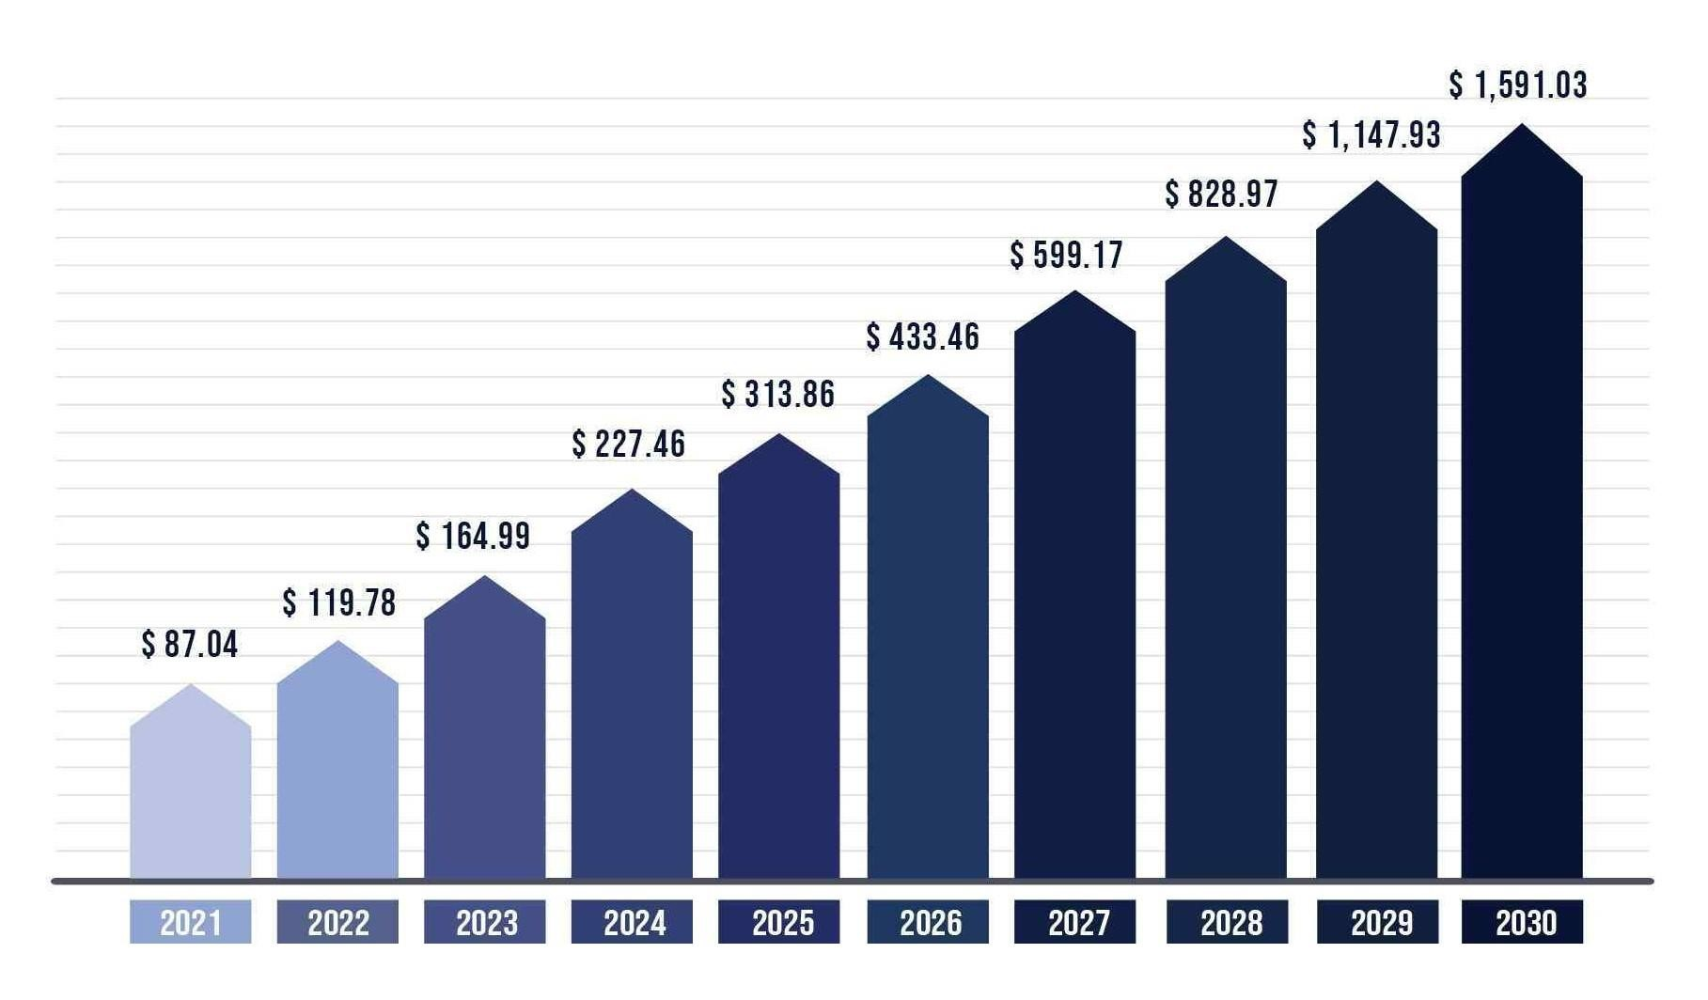

Fig 2. Google : Future scope of computer vision industry

### 2.1 PROBLEM STATEMENT

In many of the educational institutions, managing attendance of students/candidates is tedious as there would be a large number of students in the class and keeping track of all is onerous. There are situations where students act as proxies for their friends even though they are not present. Create a system, which is based on Face detection and recognition algorithms, spontaneously detects the student when he/she enters the classroom and marks the attendance by recognizing him/her. The database is then modified or updated automatically. This reduces time and effort of manually updating the attendance.

**2.2 WHY THIS PROJECT?**

Facial recognition development has received many interests in recent years. It is a critical application in image analysis yet it is very challenging to create an automated system based on facial recognition. A system with the ability to recognize human faces accurately. One application of facial recognition is in the field of attendance management system. The manual attendance system is time-consuming, thus much research has been conducted with the automatic or smart attendance management system to resolve this issue. One solution is the application of a biometric attendance management system. However, it is difficult to verify each student in the classroom as there are many students who attend the class, and if the system cannot detect or recognize one student, it will interrupt the learning process. In addition, the biometric system needs much hardware that requires high cost and a lot of interaction with the students that makes it a time consuming system. The research on applying real-time facial recognition in attendance management systems has been a real challenge. Automatic attendance marking can solve the main issues such as the error when inputting the data from the sheet to the manual attendance system, especially there is a concern that there are extremely large numbers of students in a university. The facial recognition process has many steps such as capture, extraction, comparison, and matching.

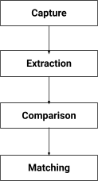

Fig 3. Face detection game plan

Face recognition is among the most productive image processing applications and has a pivotal role in the technical field. Recognition of the human face is an active issue for authentication purposes specifically in the context of attendance of students. Attendance system using face recognition is a procedure of recognizing students by using face biostatistics based on the high definition monitoring and other computer technologies. The development of this system is aimed to accomplish digitization of the traditional system of taking attendance by calling names and maintaining pen-paper records. Present strategies for taking attendance are tedious and time-consuming. Attendance records can be easily manipulated by manual recording. The traditional process of making attendance and present biometric systems are vulnerable to proxies. After face recognition attendance reports will be generated and stored in excel format. The system is tested under various conditions like illumination, head movements, the variation of distance between the student and cameras. After vigorous testing overall complexity and accuracy are calculated. The Proposed system proved to be an efficient and robust device for taking attendance in a classroom without any time consumption and manual work. The system developed is cost-efficient and needs less installation.

Choosing a face recognition attendance system as a project offers numerous advantages and opportunities for learning and innovation. Firstly, it provides a practical application of cutting-edge technologies in computer vision and machine learning. Developing a face recognition attendance system allows individuals to delve into the intricacies of face detection, feature extraction, and recognition algorithms, gaining hands-on experience in implementing these techniques.

Secondly, a face recognition attendance system addresses a real-world problem faced by many organizations and educational institutions. By automating the attendance process, it streamlines administrative tasks, reduces human errors, and enhances efficiency. This project provides an opportunity to contribute to the advancement of attendance management systems by designing an accurate, reliable, and user-friendly solution.

Moreover, the field of facial recognition is continuously evolving, with ongoing research and development. Choosing this project allows individuals to stay at the forefront of technological advancements and explore emerging trends in facial recognition systems. It encourages them to critically evaluate existing algorithms and propose novel approaches or enhancements to improve system performance and overcome challenges.

Furthermore, the project offers interdisciplinary learning opportunities, encompassing aspects of computer science, data analysis, human-computer interaction, and ethics. It involves designing a user-friendly interface, ensuring data privacy and security, and addressing ethical considerations related to the use of biometric data. This holistic approach fosters a well-rounded understanding of the technical, ethical, and societal implications of implementing facial recognition system

Lastly, the relevance and practicality of a face recognition attendance system project extend beyond the academic setting. The skills and knowledge acquired can be valuable in industry settings, where biometric-based authentication and identification systems are becoming increasingly prevalent. Completing this project equips individuals with practical expertise sought after by employers and opens doors to career opportunities in fields such as computer vision, artificial intelligence, and data analysis.

In summary, selecting a face recognition attendance system as a project offers a unique chance to explore cutting-edge technologies, solve real-world problems, contribute to advancements in the field, and gain interdisciplinary skills. It is a project that combines technical expertise, innovation, and practical applicability, making it a compelling choice for individuals seeking a challenging and impactful project experience.

## 3. OBJECTIVES

The main objectives of a facial-recognition system are :

1. **Accuracy:** The primary objective of a face recognition attendance system is to achieve accurate identification and verification of individuals based on their facial features. It aims to minimize errors and false identifications, ensuring reliable attendance records.
2. **Efficiency:** The system aims to streamline the attendance management process by automating the recording and tracking of attendance. It reduces manual efforts, saves time, and increases overall efficiency for both employees and administrators.
3. **Elimination of Proxy Attendance:** One of the key objectives of a face recognition attendance system is to eliminate proxy attendance or time theft. By uniquely identifying individuals through their facial features, the system ensures that only authorized individuals are marked present, preventing fraudulent practices.
4. **Contactless and Hygienic Solution:** In today's world, where maintaining hygiene and minimizing physical contact is important, the objective of a face recognition attendance system is to provide a contactless and hygienic solution. It eliminates the need for physical contact with attendance devices, reducing the risk of germ transmission.
5. **Integration and Compatibility:** The system aims to integrate smoothly with existing attendance management systems or other related systems, such as payroll or HR management software. Compatibility with different platforms and technologies ensures seamless data synchronization and enhances overall system effectiveness.
6. **Reporting and Analytics:** The system strives to generate comprehensive attendance reports and analytics, providing valuable insights into attendance patterns, trends, and compliance. These reports aid in decision-making processes and enable organizations to track attendance metrics effectively.
7. **Scalability:** The face recognition attendance system aims to be scalable, catering to organizations of various sizes and accommodating a large number of users. It should have the ability to handle high volumes of attendance data and adapt to changing organizational needs.

**4.PRODUCT PROTOTYPE**

The goal of this project is to evaluate various face detection and recognition methods, and provide a complete solution for image based face detection and recognition with higher accuracy. Main objective of this project is to build a system/program that would automatically mark the students attendance whenever he/she comes in front of the camera.

For this project , Our objective is to build Graphical User Interface ( GUI ) that would contain the following buttons:

1. **Register Student :** This button on clicking should ask for information about the student being registered. The information required could contain values like student's department, semester, roll-number. After the information is filled, the system should be able to click an image of the student and store it in the database/folder in format “rollnumber.jpg”
2. **Delete Student :** This button on clicking will allow for a registered student to be deleted from the database.
3. **Train Model :** On clicking this button, the machine learning model being used should get trained on the students images and recognize the facial features to mark their attendance in future.
4. **Mark Attendance :** This button on clicking will start the camera and then check whether the student in front of the camera matches someone’s face in the database and mark the attendance accordingly. Also the program will check whether the attendance of the student has already been marked or not. If marked, then the attendance would not be marked again and it would show already marked and if attendance has not been marked then it would mark the attendance of that student. After marking the attendance and output csv file would be saved containing the roll numbers of all the present students.

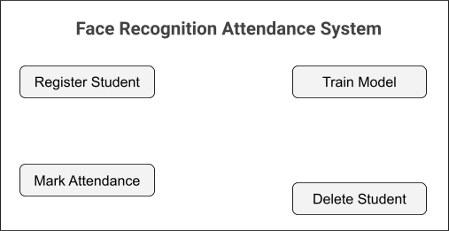

Fig 4. Gui design for attendance system

.

## 5. STEPS INVOLVED IN FACE-RECOGNITION

The facial recognition system involves several key steps in the process of recognizing and verifying individuals based on their facial features. Here are the fundamental steps typically involved in a facial recognition system:

**Face Detection**:

The first step is to detect and locate human faces within an image or video frame. Various face detection algorithms, such as Viola-Jones or Haar cascades, are commonly employed to identify facial regions based on specific features or patterns.

**Face Alignment:**

Once the faces are detected, the system aligns them to a standardized position or orientation. This step helps normalize variations in pose, scale, and rotation, ensuring consistent facial features for accurate recognition.

**Feature Extraction:**

In this step, facial features are extracted from the aligned face regions. These features include landmarks, such as eyes, nose, and mouth, or more complex representations, such as the Histogram of Oriented Gradients (HOG) or Local Binary Patterns (LBP). These features capture unique characteristics of the face that can be used for subsequent recognition.

**Feature Encoding:**

The extracted facial features are encoded into a compact representation or a numerical vector, often referred to as a face embedding or face descriptor. This encoding aims to capture essential discriminative information while reducing the dimensionality of the data.

**Database Creation:**

The system builds a database or repository of face embeddings by collecting and storing the encoded features of individuals in a structured manner. Each face embedding is associated with an identity label or metadata to facilitate identification and verification.

**Training the Recognition Model:**

The face recognition model is trained using the collected face embeddings and associated identity labels. Machine learning algorithms, such as Support Vector Machines (SVM), Neural Networks, or more advanced techniques like Deep Learning-based Convolutional Neural Networks (CNN), are often employed to learn patterns and relationships in the face data.

**Recognition and Verification:**

To recognize a face, the system compares the face embedding of an input image or video frame with the face embeddings stored in the database. This involves computing a similarity or distance measure, such as Euclidean distance or Cosine similarity, to determine the closest matches or potential identity of the input face.

**Decision and Post-processing**:

Based on the similarity scores, a decision is made to identify or verify the individual's identity. Post-processing steps may include thresholding the similarity scores, applying additional rules for decision-making, or considering temporal consistency in video-based scenarios.

**System Evaluation and Optimization:**

The performance of the facial recognition system is evaluated using metrics such as accuracy, precision, recall, and F1-score. The system may be optimized by fine-tuning parameters, incorporating feedback, or retraining the model with new data to improve its performance. These steps collectively form the core process of a facial recognition system, enabling the identification and verification of individuals based on their facial features.

Three basic steps are used to develop a robust face recognition system: (1) face detection, (2) feature extraction, and (3) face recognition. The face detection step is used to detect and locate the human face image obtained by the system. The feature extraction step is employed to extract the feature vectors for any human face located in the first step. Finally, the face recognition step includes the features extracted from the human face in order to compare it with all template face databases to decide the human face identity.

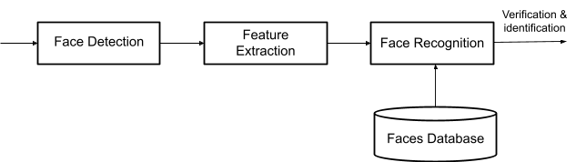

Fig 5. Face-recognition steps

**Face Detection**: The face recognition system begins first with the localization of the human faces in a particular image. The purpose of this step is to determine if the input image contains human faces or not. The variations of illumination and facial expression can prevent proper face detection. In order to facilitate the design of a further face recognition system and make it more robust, pre-processing steps are performed. Many techniques are used to detect and locate the human face image, for example, histogram of oriented gradient (HOG) , and principal component analysis (PCA). Also, the face detection step can be used for video and image classification, object detection , region-of-interest detection , and so on.

**Feature Extraction**: The main function of this step is to extract the features of the face images detected in the detection step. This step represents a face with a set of feature vectors called a “signature” that describes the prominent features of the face image such as mouth, nose, and eyes with their geometry distribution. Each face is characterized by its structure, size, and shape, which allow it to be identified. Several techniques involve extracting the shape of the mouth, eyes, or nose to identify the face using the size and distance .

**Face Recognition**: This step considers the features extracted from the background during the feature extraction step and compares it with known faces stored in a specific database. There are two general applications of face recognition, one is called identification and another one is called verification. During the identification step, a test face is compared with a set of faces aiming to find the most likely match. During the identification step, a test face is compared with a known face in the database in order to make the acceptance or rejection decision . Correlation filters (CFs) , convolutional neural network (CNN) , and also k-nearest neighbor (KNN) are known to effectively address this task.

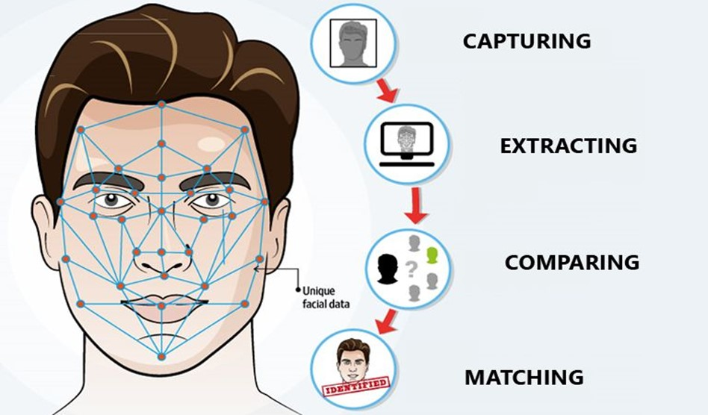

Fig 6. Google : Face recognition workflow

## 6. FEASIBILITY STUDY

### 5.1 FEASIBILITY

A feasibility study is an important tool for decision-making, as it provides stakeholders with a clear understanding of the project's potential benefits and risks. It involves evaluating the technical, economic, operational, legal, and scheduling aspects of the project to determine whether it is feasible to undertake. The study can also help identify potential issues and challenges that need to be addressed before the project can proceed.

The main purpose of a feasibility study is to identify potential challenges and risks associated with the project and determine whether the project is worth pursuing. The study typically includes a detailed analysis of the project's goals, scope, and objectives, as well as an assessment of the resources required to complete the project.

Face recognition from image or video is a popular topic in biometrics research. Many public places usually have surveillance cameras for video capture and these cameras have their significant value for security purposes. It is widely acknowledged that face recognition has played an important role in surveillance systems as it doesn’t need the object’s cooperation. The actual advantages of face based identification over other biometrics are uniqueness and acceptance. As the human face is a dynamic object having a high degree of variability in its appearance, that makes face detection a difficult problem in computer vision. In this field, accuracy and speed of identification is a main issue.

The feasibility study for a face recognition attendance system aims to assess the practicality and viability of implementing such a system within an organization or educational institution. The study evaluates various factors, including technical, economic, operational, and legal aspects, to determine if the system is feasible and beneficial.

### OPERATIONAL FEASIBILITY

The operational feasibility of a face recognition attendance system refers to its practicality and effectiveness in real-world operational scenarios. It involves assessing various factors to determine if the system can be successfully implemented and utilized. Here are some considerations for the operational feasibility of a face recognition attendance system:

* **Accuracy and Reliability**: The system must have a high level of accuracy and reliability in recognizing and verifying individuals' faces. It should be able to handle variations in lighting conditions, pose, facial expressions, and occlusions to ensure accurate attendance tracking.
* **Scalability:** The system should be scalable to accommodate a large number of users, especially in scenarios where attendance needs to be recorded for a significant number of individuals, such as in educational institutions or workplaces.
* **Speed and Efficiency:** The system should be capable of real-time or near real-time processing to provide efficient attendance tracking without causing significant delays or disruptions. The face recognition algorithm should be optimized for quick identification and verification.
* **User Acceptance:** The system should be user-friendly and easily understandable by the individuals using it. Training and guidance may be necessary to ensure that users can interact with the system comfortably and have a positive experience.
* **Integration with Existing Infrastructure:** The feasibility of integrating the face recognition attendance system with the existing infrastructure and technologies should be considered. This includes compatibility with existing databases, attendance management systems, and hardware devices (e.g., cameras or sensors).
* **Legal and Ethical Compliance:** Compliance with legal and ethical considerations, such as data protection regulations and informed consent, should be ensured when implementing a face recognition attendance system.

### ECONOMICAL FEASIBILITY

The economic feasibility of a face recognition attendance system involves evaluating its cost-effectiveness and financial viability. It assesses the economic benefits and potential return on investment (ROI) compared to the costs associated with implementing and maintaining the system. Here are some considerations for the economic feasibility of a face recognition attendance system:

* **Cost of Implementation:** This includes the initial investment required to set up the system, such as purchasing the necessary hardware (cameras, sensors) and software licenses. The costs may also include any required infrastructure upgrades or modifications.
* **Operational Costs:** These costs include ongoing expenses for system maintenance, software updates, hardware upgrades, and technical support. Consideration should be given to the long-term expenses associated with running and maintaining the system.
* **Cost Savings:** Evaluate the potential cost savings compared to traditional attendance tracking methods. This may include reductions in labor costs for manual attendance monitoring, paper-based processes, or swipe-card systems. The automation provided by the face recognition system can streamline attendance tracking and reduce administrative overhead.
* **Time Savings:** Consider the time saved by using an automated face recognition attendance system compared to manual processes. This can result in increased productivity and efficiency for both employees and administrative staff.
* **Accuracy and Reduction in Errors:** Assess the potential reduction in errors and inaccuracies associated with manual attendance tracking. The face recognition system can minimize instances of proxy attendance or recording errors, leading to improved accuracy and data integrity.
* **Return on Investment (ROI):** Calculate the potential ROI by comparing the overall benefits and cost savings achieved through the implementation of the system. The ROI analysis should consider factors such as labor cost savings, increased productivity, and improved accuracy.
* **Comparative Analysis:** Compare the economic feasibility of the face recognition attendance system with alternative solutions or technologies available in the market. Consider the cost-effectiveness, features, and benefits provided by different systems to determine the most economically viable option.
* **Scalability and Future Expansion:** Consider the system's scalability and ability to handle future growth or additional features. Evaluate the potential for the system to adapt to changing needs and accommodate an increasing number of users or locations.

### TECHNICAL FEASIBILITY

The technical feasibility of a face recognition attendance system refers to its ability to be implemented and function effectively from a technical standpoint. It involves assessing various technical aspects to determine if the system can be successfully developed, integrated, and operated. Here are some considerations for the technical feasibility of a face recognition attendance system:

* **Face Recognition Algorithm:** Evaluate the performance and accuracy of the face recognition algorithm that will be used. Consider factors such as the algorithm's robustness to variations in lighting conditions, pose, facial expressions, and occlusions. Ensure that the algorithm can handle the expected range of faces and provide reliable identification and verification.
* **Hardware Requirements:** Assess the hardware requirements for the face recognition system, including cameras or sensors used for capturing facial images. Consider factors such as camera resolution, image quality, and processing power. Ensure that the hardware is capable of capturing clear and high-quality images required for accurate face recognition.
* **Processing and Storage Capacity:** Evaluate the processing power and storage capacity needed to handle the computational requirements of the face recognition system. Consider the number of users, the frequency of attendance tracking, and the real-time processing demands. Ensure that the system can handle the expected workload without performance bottlenecks.
* **Integration with Existing Infrastructure:** Determine the feasibility of integrating the face recognition attendance system with existing infrastructure and systems. This may include compatibility with attendance management software, databases, access control systems, or other relevant technologies. Ensure that the system can seamlessly integrate and communicate with the existing infrastructure.
* **User Interface and Experience:** Evaluate the user interface of the system to ensure that it is intuitive, user-friendly, and accessible. Consider the ease of use for both administrators and end-users. The system should provide clear instructions, feedback, and an efficient workflow for attendance tracking.
* **Environmental Factors:** Assess the impact of environmental factors on the system's performance. Consider factors such as lighting conditions, temperature, and physical constraints in the deployment environment. Ensure that the system can operate effectively and consistently under expected environmental conditions.

### 5.2 NEED FOR FACE RECOGNITION ATTENDANCE SYSTEM

In many of the educational institutions, managing attendance of students/candidates is tedious as there would be a large number of students in the class and keeping track of all is onerous. There are situations where students act as proxies for their friends even though they are not present. This System, which is based on Face detection and recognition algorithms, spontaneously detects the student when he/she enters the classroom and marks the attendance by recognizing him/her. The database is then modified or updated automatically. This reduces time and effort of manually updating the attendance.

Face recognition is among the most productive image processing applications and has a pivotal role in the technical field. Recognition of the human face is an active issue for authentication purposes specifically in the context of attendance of students. Attendance system using face recognition is a procedure of recognizing students by using face biostatistics based on the high definition monitoring and other computer technologies. The development of this system is aimed to accomplish digitization of the traditional system of taking attendance by calling names and maintaining pen-paper records. Present strategies for taking attendance are tedious and time-consuming. Attendance records can be easily manipulated by manual recording. The traditional process of making attendance and present biometric systems are vulnerable to proxies. After face recognition attendance reports will be generated and stored in excel format. The system is tested under various conditions like illumination, head movements, the variation of distance between the student and cameras. After vigorous testing overall complexity and accuracy are calculated. The Proposed system proved to be an efficient and robust device for taking attendance in a classroom without any time consumption and manual work. The system developed is cost-efficient and needs less installation.

A face recognition attendance system offers several advantages over traditional attendance systems.

Here are some key reasons why a face recognition attendance system may be beneficial:

**Accuracy and Elimination of Proxy Attendance**: Face recognition technology provides a high level of accuracy in identifying individuals. It reduces the chances of proxy attendance or time theft since each person's attendance is uniquely tied to their face, making it difficult to manipulate or deceive the system.

**Contactless and Hygienic**: With face recognition attendance systems, there is no need for physical contact or touch-based methods such as fingerprint or card scanners. This makes it a hygienic solution, particularly in environments where maintaining cleanliness and minimizing physical contact is important, such as in healthcare facilities or during a pandemic.

**Efficient and Time-Saving**: Face recognition attendance systems can quickly and efficiently identify and record attendance without the need for manual processes. It eliminates the need for employees or students to physically sign in or swipe cards, saving time and reducing administrative efforts.

**Scalability and Flexibility**: Face recognition attendance systems can handle large numbers of individuals and can be easily scaled to accommodate organizations of various sizes. The technology can be integrated with existing systems or incorporated into new setups, providing flexibility and adaptability to different environments.

**Enhanced Security:** Face recognition offers an added layer of security compared to traditional attendance systems. It reduces the risk of identity fraud or unauthorized access since each individual's unique facial features are used for verification. It can also be combined with other security measures, such as access control systems, to enhance overall security.

Overall, a face recognition attendance system combines accuracy, efficiency, scalability, and security, making it a valuable solution for organizations looking to streamline attendance management processes and improve overall productivity.

## 7. METHODOLOGY

### 7.1 SOFTWARE DEVELOPMENT LIFE CYCLE

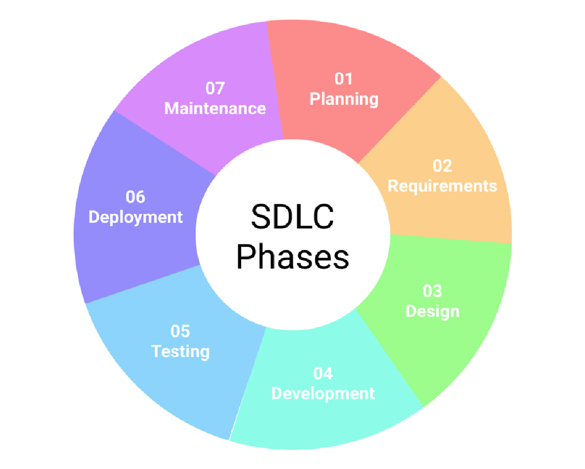

Fig 7. Google : SDLC

1. **Planning**: In this stage, the project's objectives, requirements, and scope are defined, and a plan is developed to guide the project's execution.
2. **Analysis:** In this stage, the system's requirements are analyzed and defined, including the data sources, features, and functionality required for the face recognition model.
3. **Design:** In this stage, the project's architecture is designed, including the face recognition model's structure, the database design, and the user interface.
4. **Development:** In this stage, the project's code is developed, including the implementation of the face recognition model, The database creation, and the user interface development.
5. **Testing:** In this stage, the system is tested to ensure that it meets the project's requirements, including the performance, accuracy, and reliability of the face recognition model.

### 7.2 TOOLS USED



Fig 8. Tools used in project

### 8.1 VARIOUS FACE RECOGNITION TECHNIQUES

**PCA ( Principal component analysis) :-** Face recognition using Principal Component Analysis (PCA) is a popular technique in computer vision for identifying individuals based on their facial features. PCA is a dimensionality reduction method that extracts the most significant features from a set of facial images, allowing for efficient representation and comparison. By projecting the face images onto a lower-dimensional space, PCA captures the main variations in the dataset.

However, there are limitations to PCA-based face recognition. Firstly, PCA assumes that the facial features follow a linear distribution, which may not hold true in all cases. Additionally, PCA is sensitive to variations in lighting conditions, pose, and expression, leading to reduced accuracy in real-world scenarios. Moreover, PCA relies on the assumption that the face images are well-aligned and contain sufficient information, making it less effective when dealing with occlusions, disguises, or low-quality images. These limitations highlight the need for more advanced algorithms that can address these challenges and improve the accuracy and robustness of face recognition systems.

**PCA + ANN (Artificial Neural Networks)** :- Face recognition using Principal Component Analysis (PCA) in combination with Artificial Neural Networks (ANN) is a powerful approach for identifying individuals based on their facial features. PCA is employed as a dimensionality reduction technique to extract the most discriminative features from facial images, while ANN acts as a classifier to learn the complex patterns and make accurate predictions. PCA reduces the dimensionality of the feature space, making it computationally efficient and reducing the risk of overfitting. The extracted features are then fed into an ANN, which consists of multiple layers of interconnected artificial neurons. The ANN learns from the training data to recognize the unique patterns associated with different individuals. However, PCA+ANN face recognition also has its limitations. One major drawback is the need for a large and diverse training dataset to capture the variations in facial appearances adequately. Insufficient training data may result in poor generalization and lower accuracy. Additionally, PCA+ANN face recognition systems are still susceptible to variations in pose, lighting conditions, and facial expressions. The robustness of the system can be compromised if the training data does not cover a wide range of these variations. Furthermore, occlusions, disguises, and low-quality images can pose challenges for accurate recognition. To address these limitations, researchers continue to explore advanced techniques, such as deep learning architectures, to enhance the performance of face recognition systems based on PCA+ANN.

**PCA + EIGENFACES :-** Face recognition using Principal Component Analysis (PCA) with Eigenfaces is a widely used technique for identifying individuals based on their facial features. Eigenfaces are the eigenvectors of the covariance matrix calculated from a training set of face images. These eigenvectors represent the principal components of the face images, capturing the main variations in facial appearance. By projecting a face image onto the eigenvector space, a low-dimensional representation of the face is obtained. During recognition, the input face image is projected onto the same eigenvector space, and the nearest neighbor or a classifier is used to determine the identity.

However, there are certain limitations and drawbacks to using PCA with Eigenfaces for face recognition. Firstly, Eigenfaces assume linearity in facial appearance variations, which may not hold true in all cases. Non-linear variations, such as extreme poses or complex expressions, can result in reduced accuracy. Additionally, Eigenfaces are sensitive to lighting conditions and variations, which can cause significant changes in facial appearance. Furthermore, Eigenfaces do not handle occlusions or partial face images well, as they rely on the availability of complete facial features for accurate recognition.

**KNN (K- Nearest Neighbours)** :- Face recognition using the k-Nearest Neighbors (k-NN) algorithm is a popular technique for identifying individuals based on their facial features. The k-NN algorithm is a non-parametric method that classifies new instances based on their similarity to the labeled instances in the training dataset. In the context of face recognition, the k-NN algorithm measures the distance between a test face and the faces in the training set, and assigns the test face the label of the majority of its k nearest neighbors.

One of the advantages of using the k-NN algorithm for face recognition is its simplicity and ease of implementation. It does not require complex training processes or extensive parameter tuning. Additionally, the k-NN algorithm can adapt well to variations in facial appearance, as it considers the entire feature space and does not assume any specific distribution of data.

However, the k-NN algorithm also has its limitations. One drawback is its computational cost, particularly when dealing with large training datasets. As the number of training instances increases, the time required to find the k nearest neighbors grows significantly. This can hinder the real-time performance of the face recognition system. Additionally, the accuracy of the k-NN algorithm can be affected by the choice of the k value. A small k value may lead to noise or outliers influencing the classification, while a large k value may smooth out important local patterns and decrease accuracy.

Furthermore, the k-NN algorithm is sensitive to the choice of distance metric. The selection of an appropriate distance metric is crucial to ensure that similar faces are correctly identified and dissimilar faces are effectively distinguished. Different distance metrics, such as Euclidean distance or cosine similarity, may yield varying results depending on the dataset and application.

In summary, while the k-NN algorithm offers simplicity and adaptability for face recognition, its limitations include computational complexity, sensitivity to the choice of k and distance metric, and the potential for reduced accuracy in certain scenarios. These factors need to be considered when implementing a face recognition system using the k-NN algorithm

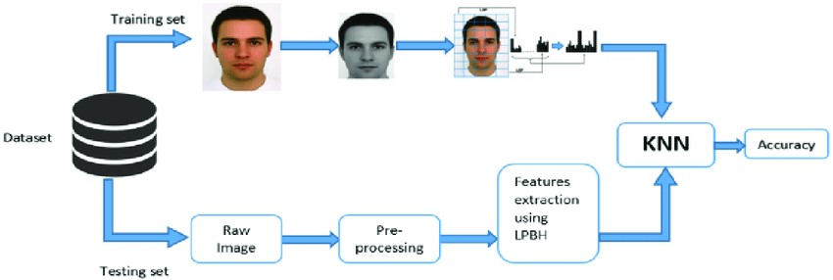

Fig 10. Google: face recognition with KNN

**Viola-Jones Algorithm :-** Face recognition using the Viola-Jones algorithm is a popular and efficient technique for detecting and recognizing faces in images or video streams. The Viola-Jones algorithm is based on a combination of Haar-like features, a cascading classifier, and integral images. Viola-Jones algorithm is a popular and efficient algorithm for face detection developed by Paul Viola and Michael Jones.

Several steps followed by viola jones algorithm consists of following steps:

* **Haar-like Features:**

The algorithm starts by extracting Haar-like features from the input image. Haar-like features are rectangular regions that capture local intensity variations in the image. These features are calculated by subtracting the sum of pixel intensities in the white region from the sum of pixel intensities in the black region.

A large set of these features is generated, capturing different patterns that are characteristic of faces.These features include variations in edges, lines, and texture.

* **Integral Images:**

To speed up the process, integral images are utilized. Integral images are used to speed up the computation of Haar-like features. An integral image represents the sum of pixel intensities up to a given position in the original image. Integral images allow rapid calculation of the sum of pixel intensities within any rectangular region of the image. This reduces the computational complexity of evaluating Haar-like features. By calculating the integral image, the sum of pixel intensities within any rectangular region of the image can be obtained quickly.

* **Cascading Classifier:**

Next,The Viola-Jones algorithm employs a cascading classifier to efficiently detect faces. The cascading classifier consists of multiple stages, each containing a set of weak classifiers. Each weak classifier is a simple rule that decides whether a particular region of the image is likely to contain a face or not. These rules are typically based on the evaluation of Haar-like features. The weak classifiers are organized in a cascading structure, where the easy-to-classify regions are rejected in earlier stages, reducing the computational burden for subsequent stages.

The cascading nature of the classifier allows for fast rejection of non-face regions, reducing the computational burden.

* **Training:**

The algorithm is trained using a large dataset of positive (face) and negative (non-face) examples. During training, the algorithm iteratively selects the most discriminative Haar-like features and adjusts the weights of the weak classifiers to achieve high accuracy in face detection.

The AdaBoost algorithm is commonly used for feature selection and weight adjustment. It assigns higher weights to misclassified samples and lower weights to correctly classified samples to focus on the challenging regions.

* **Face Detection:**

During face detection, the algorithm applies the cascading classifier to sliding windows of different sizes across the image. At each stage, the Haar-like features within the window are evaluated using integral images.

If the features satisfy the thresholds set by the weak classifiers, the region is considered a potential face and moves to the next stage. Otherwise, it is quickly rejected, reducing the computational load.

The final stage combines the decisions of all weak classifiers, and if the region passes all stages, it is classified as a face detection.

The Viola-Jones algorithm is known for its real-time performance and high detection rates. It has been widely used in various face detection applications due to its effectiveness and efficiency. However, it also has some limitations. It is sensitive to variations in lighting conditions, pose, and occlusions. Faces that deviate significantly from the training set or have complex appearances may not be accurately detected. Additionally, the Viola-Jones algorithm may produce false positives or false negatives in certain scenarios.

Despite its limitations, the Viola-Jones algorithm has been widely adopted in various applications due to its speed and effectiveness in face detection. It serves as a fundamental component in many face recognition systems, and researchers continue to enhance its capabilities to address the challenges posed by real-world scenarios.

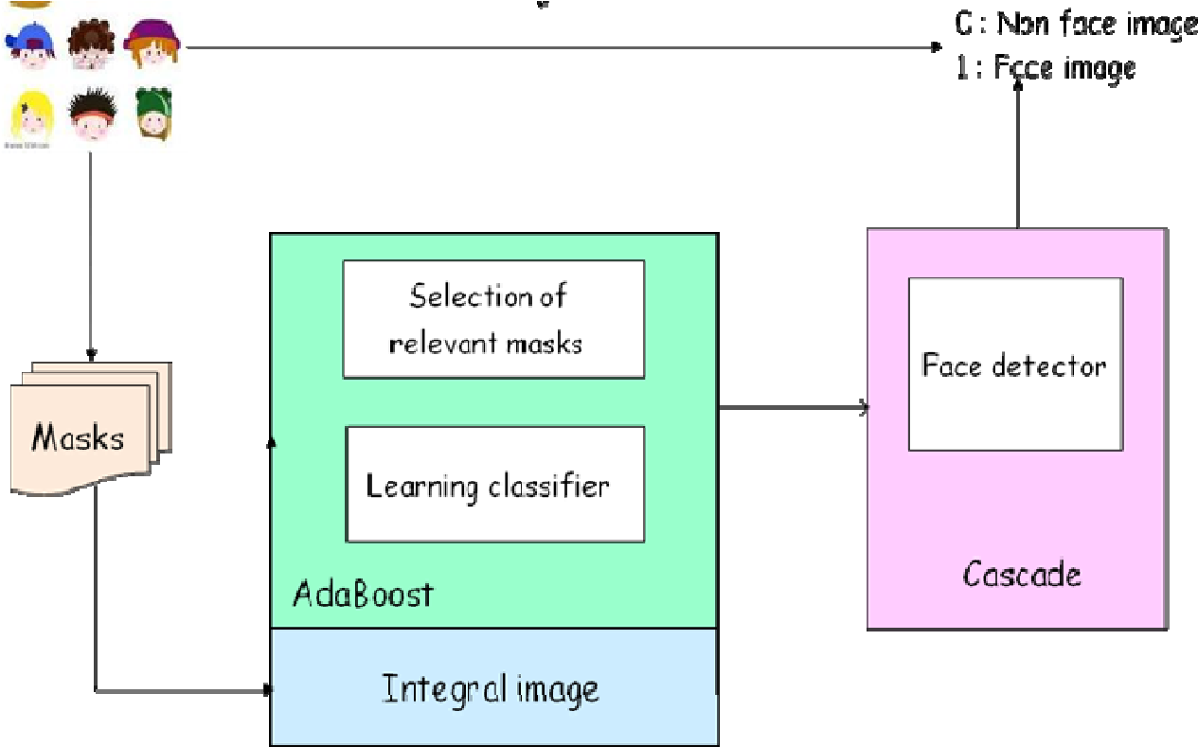

Fig 11. Google: Face recognition with Viola Jones

**HOG (Histogram of Gradients)** :- Face recognition using the Histogram of Oriented Gradients (HOG) algorithm is a robust technique that captures the local gradient patterns in images for accurate face detection and recognition. The HOG algorithm operates by extracting and analyzing the distribution of gradient orientations within a given image.

The Histogram of Oriented Gradients (HOG) algorithm is a popular method for object detection and recognition. It is widely used for tasks such as pedestrian detection and face recognition.

Here's an overview of how the HOG algorithm works:

* **Image Preprocessing:**

The algorithm starts by preprocessing the input image. This may involve converting the image to grayscale and applying optional preprocessing steps such as gamma correction or histogram equalization.

To begin, the algorithm divides the image into small overlapping cells, typically square or rectangular in shape. Within each cell, the gradient magnitudes and orientations are calculated using techniques like the Sobel operator. The image gradients provide information about the local intensity variations, which can be indicative of facial features.

* **Gradient Computation:**

The next step involves computing the gradients within the image. Gradients capture the local intensity variations and provide information about the edges and boundaries of objects. Typically, the gradients are computed using techniques like the Sobel operator. The image is convolved with horizontal and vertical Sobel filters to calculate the gradient magnitude and orientation at each pixel.

* **Gradient Orientation Binning:**

Next, a histogram of gradient orientations is constructed for each cell. The image is divided into small overlapping cells, typically square or rectangular in shape. Each cell contains a group of pixels. The histogram counts the occurrences of different gradient orientations within the cell. The orientations are often binned into several bins or angular ranges, such as 0-20 degrees, 20-40 degrees, and so on.The magnitudes are often used to weight the contributions of the orientations. The magnitude of each gradient is also considered to weight the contribution of the corresponding orientation.

* **Histogram Formation:**

For each cell, a histogram of gradient orientations is constructed by accumulating the number of occurrences of each orientation in the respective bins.

The histogram captures the distribution of gradients within the cell and represents the local texture information.

* **Block Normalization:**

To capture spatial relationships, the cells are grouped into larger blocks. The cells are grouped into larger blocks to capture more spatial information and normalize the gradients. Blocks can overlap or be non-overlapping. The histograms of the cells within a block are concatenated or normalized to create a block-level descriptor. This allows the algorithm to capture more global patterns in facial features.

Normalization techniques like L1-norm, L2-norm, or block-wise normalization can be applied to ensure that the descriptor is invariant to overall illumination changes or contrast variations.

* **Feature Vector:**

Finally, all the block-level descriptors are combined to form a feature vector that represents the face image or the object or region of interest. This feature vector can then be compared to a set of known face templates or used for classification using techniques like Support Vector Machines (SVM) or Neural Networks.

The HOG algorithm excels in capturing the shape and texture information in faces, making it effective for face detection and recognition tasks. It is robust to variations in lighting conditions, pose, and occlusions, as the gradients capture the local structure of facial features rather than relying on specific pixel values. Additionally, the HOG algorithm can be computationally efficient by using techniques like integral images and sliding windows to analyze different image regions.

HOG captures detailed texture and edge information through gradient analysis, allowing it to better handle variations in lighting conditions, pose, and occlusions. It can capture the shape and structure of objects more effectively, making it suitable for applications that require precise object localization and recognition.

However, the HOG algorithm also has some limitations. It may struggle with extreme variations in facial appearance or complex expressions, as the gradient information alone may not be sufficient to capture such nuances. Additionally, the performance of the HOG algorithm heavily relies on proper parameter tuning, including the size of the cells, the number of bins in the histograms, and the arrangement of the blocks.

In conclusion, the Histogram of Oriented Gradients (HOG) algorithm is a powerful method for face recognition that leverages gradient information to capture local patterns and detect faces accurately. While it has some limitations, the HOG algorithm remains a valuable tool in face recognition systems, particularly when combined with other techniques to handle more challenging scenarios.

### 7.2 COMPARISON OF FACE RECOGNITION TECHNIQUES

|  |  |  |  |
| --- | --- | --- | --- |
| **S.NO** | **TECHNIQUE** | **RECOGNITION RATE** | **LIMITATIONS** |
| 1. | Principal Component Analysis (PCA) | 56% | Low accuracy in lighting and Repeat image capturing |
| 2. | PCA + Eigenfaces | 90% | Validation of the student once marked is not done |
| 3. | PCA + ANN | 88% | High Computational cost  due to combining PCA and  ANN |
| 4. | KNN ( k- Nearest Neighbours ) | 93% | Requires large amounts of data (images) for training. |
| 5. | Viola-Jones Algorithm | 96% | Computational efficiency, Highly resource-intensive |
| 6. | HOG ( Histogram of  gradients) | 97% | Sensitive to image rotation |

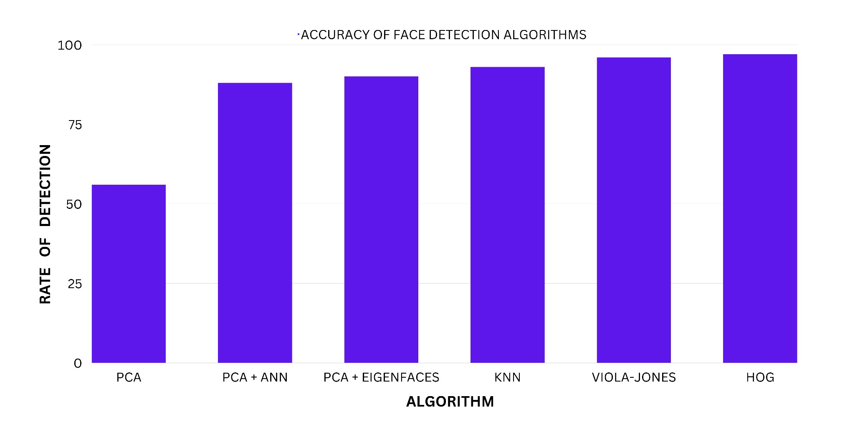

Fig 12. Comparison of various algorithms

### 8.3 FACE RECOGNITION TECHNIQUE USED AND WHY

After exhaustive study of face recognition techniques and algorithms,The Face Recognition technique selected and used for this project is **HOG.**

The Histogram of Oriented Gradients (HOG) technique has revolutionized face recognition with its robust and accurate feature extraction capabilities. HOG operates on the principle that the distribution of local gradient directions in an image can effectively represent the underlying shape and texture information. By dividing the image into small cells and computing the histograms of gradient orientations within these cells, HOG captures the local patterns and gradients that are essential for distinguishing facial features. This technique is particularly adept at handling variations in lighting conditions, making it highly suitable for real-world scenarios.

Furthermore, HOG has demonstrated resilience against occlusions, facial expressions, and moderate pose variations, making it a reliable choice for face recognition tasks. The HOG technique has seen various advancements, such as the incorporation of spatial pyramid structures and integration with deep learning approaches, which have further improved its accuracy and applicability. Despite its effectiveness, HOG does have limitations, such as its sensitivity to image resolution and its computational complexity, which may hinder its real-time performance. Nonetheless, with ongoing research and advancements, HOG continues to be a valuable tool in the field of face recognition, offering promising opportunities for further improvements and applications.

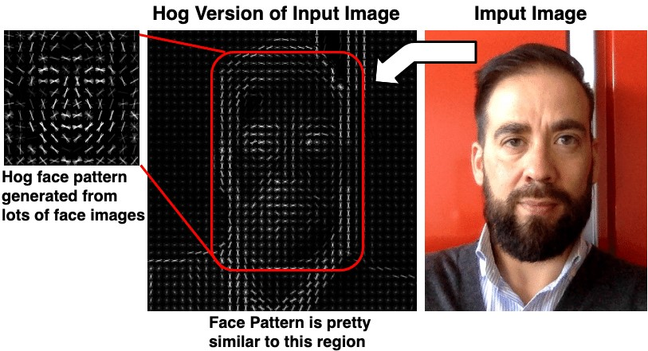

Fig 13. google : How HOG views images

Factors leading to select HOG algorithm over Viola-Jones algorithm :

1. **Robustness to varying lighting conditions**: HOG-based methods tend to handle variations in lighting conditions better than Viola-Jones. HOG focuses on capturing the distribution of gradients in an image, making it more resilient to changes in illumination.
2. **Better performance with occlusions and facial expressions**: HOG can be more effective in detecting faces that are partially occluded or have extreme facial expressions. Its feature extraction process captures local patterns and textures, which helps in recognizing faces even when some parts are obscured.
3. **Flexibility in pose and rotation**: HOG-based approaches can handle face detection across a wider range of poses and rotations compared to the Viola-Jones algorithm. The gradient-based features of HOG are less sensitive to these variations, enabling better detection performance.
4. **Availability of pre-trained models**: HOG-based face detection models, such as the dlib library, often come with pre-trained models that are readily available. These models have been trained on large datasets and can provide good out-of-the-box performance for face detection tasks.
5. **Customization and extensibility:** HOG offers more flexibility for customization and fine-tuning of parameters. You can experiment with different configurations, such as adjusting cell sizes or histogram binning techniques, to optimize the performance based on your specific requirements.
6. **Feature Expressiveness:** HOG provides more expressive and detailed features compared to the Haar-like features used in the Viola-Jones algorithm. The gradient-based approach of HOG captures edge and texture information, which can be useful for recognizing objects with intricate structures.

Another major reason for using histogram of gradients technique over other algorithms is that HOG captures detailed texture and edge information through gradient analysis, allowing it to better handle variations in lighting conditions, pose, and occlusions. It can capture the shape and structure of objects more effectively, making it suitable for applications that require precise object localization and recognition.

### 8.4 WORKING OF HOG ALGORITHM

The HOG (Histogram of Gradients) technique counts occurrences of gradient orientation in the localized portion of an image. This method is quite similar to Edge Orientation Histograms and Scale Invariant aFeature Transformation (SIFT). The HOG descriptor focuses on the structure or the shape of an object. It is better than any edge descriptor as it uses magnitude as well as angle of the gradient to compute the features. For the regions of the image it generates histograms using the magnitude and orientations of the gradient.

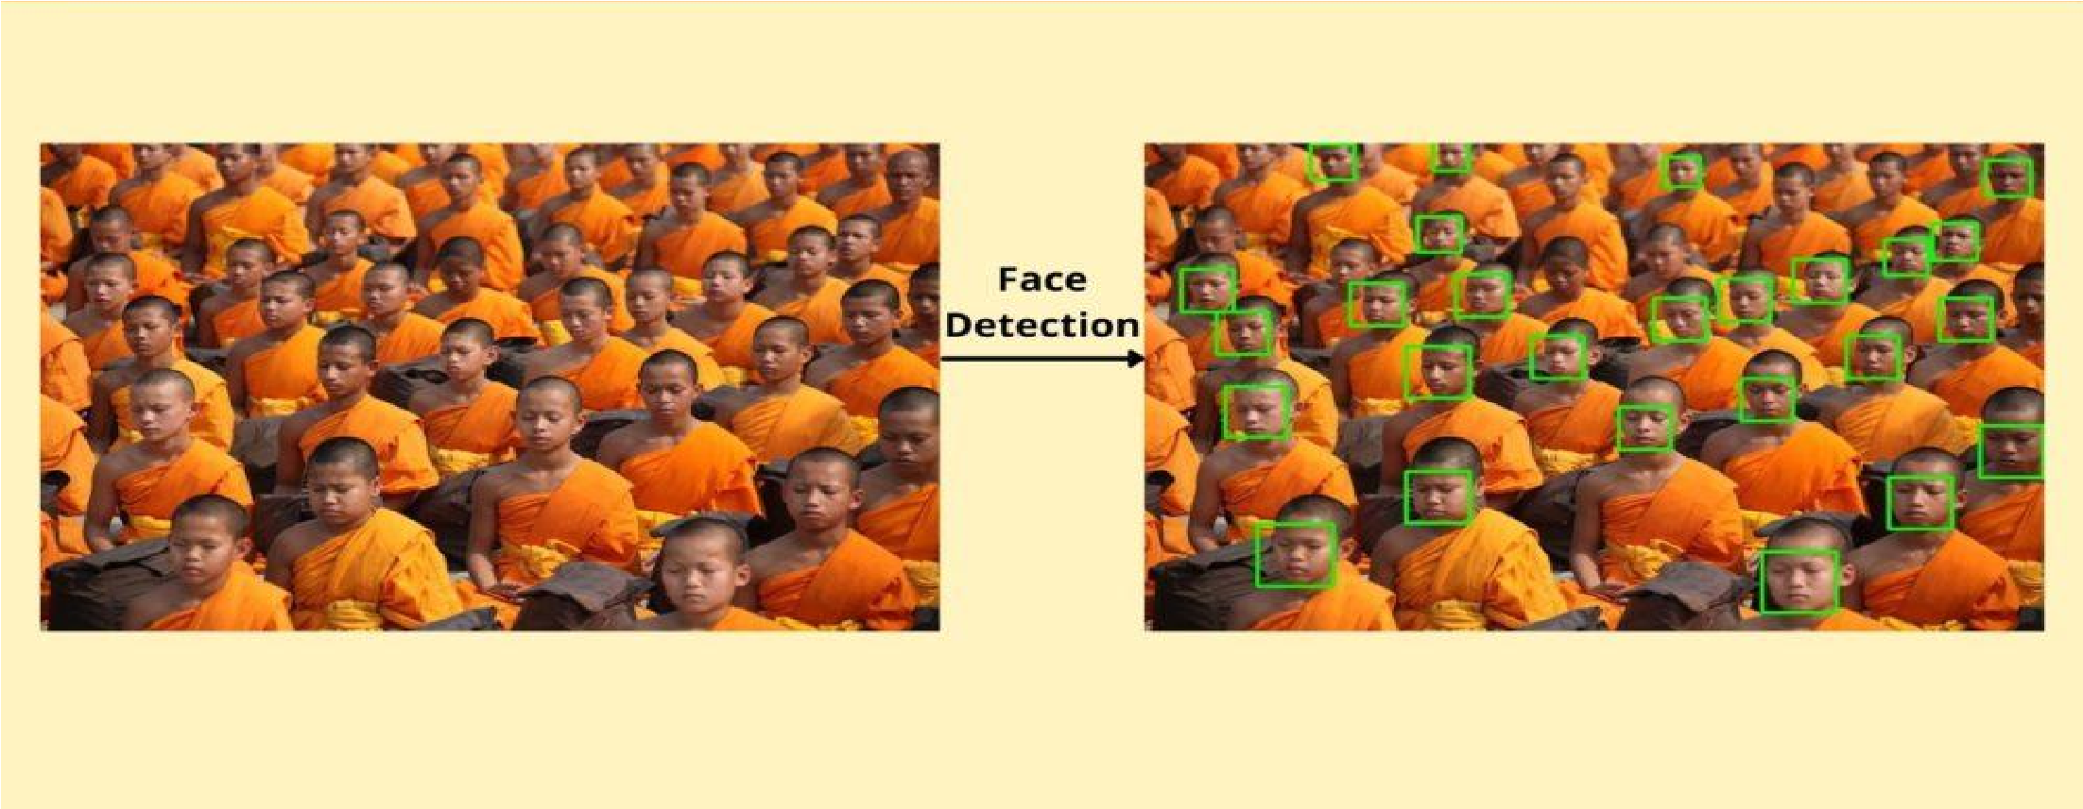

Fig 14. Google :Face recognition with HOG

Steps involved in HOG algorithm :

1. **Cellular Division :** The basic idea of HOG is dividing the image into small connected cells

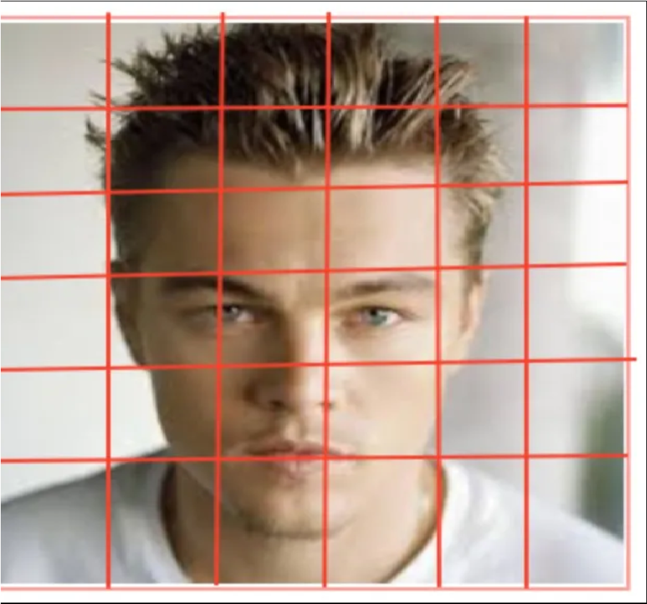

Fig 15. Google : Dividing image to small connected cells

1. **Calculating Gradients (direction x and y) :** Gradients are the small change in the x and y directions. In this step we Compute histogram for each cell. It calculates gradients like small boxes containing information about the intensity of that portion . In short Information about the features of the face.

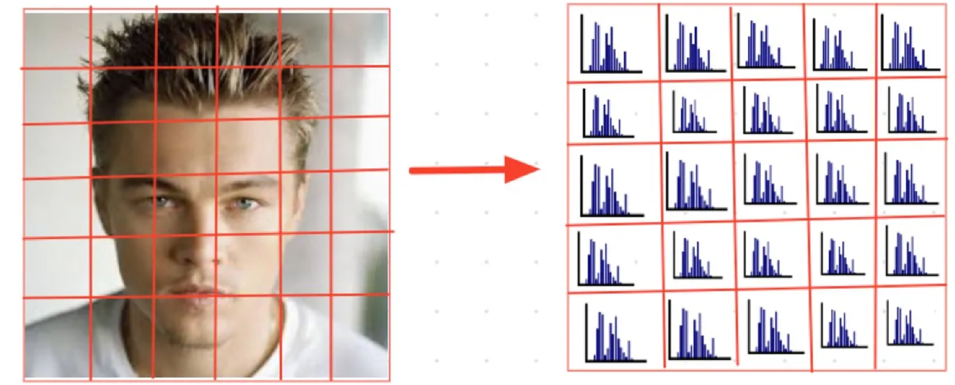

Fig 16. google: Computing Gradient for each cell

1. **Formation of Feature Vector :** Bring all histograms together to form feature vector i.e., it forms one histogram from all small histograms which is unique for each face.

Optionally, the final feature vector can be further normalized across different blocks or the entire image to improve the robustness and discriminative power of the feature representation.

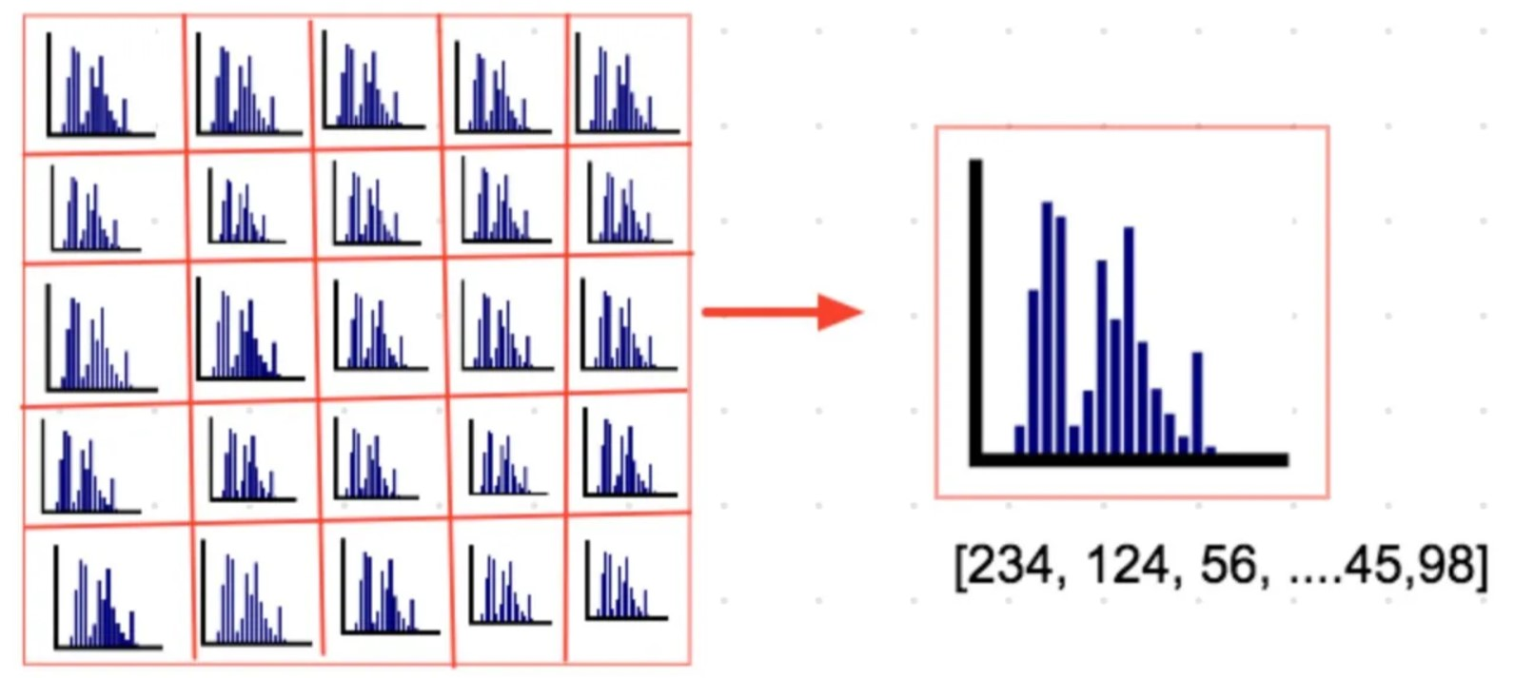

Fig 17. Google: Formation of Feature Vector

Face recognition with the Histogram of Oriented Gradients (HOG) algorithm is a popular and effective approach in the field of computer vision. HOG-based face recognition focuses on capturing the local gradient orientations of facial features to create a descriptor that represents the unique characteristics of each individual's face. By analyzing the distribution of gradients across the face, the HOG algorithm can robustly identify faces and differentiate them from other objects or backgrounds.This technique offers several advantages, including resistance to lighting variations and pose changes. HOG-based face recognition has been widely used in various applications, such as security systems and surveillance, showcasing its capability to accurately and efficiently recognize individuals based on their facial features.

### 8.5 DISADVANTAGE OF USING HOG ALGORITHM

The disadvantage with HOG based face detection is that it doesn’t work on faces at odd angles, it only works with straight and front faces. I.e This algorithm is Sensitive to image rotation which sometimes makes it not the best solution to use for real time detection.

Also, While HOG tends to offer higher accuracy, it also comes with a higher computational cost. HOG requires more computational resources and processing time due to the calculation of gradients and the construction of histograms.

## 11. DISCUSSION

The discussion section of this project presents a comprehensive analysis and evaluation of the use of various technologies, including the HOG algorithm, Tkinter, CustomTkinter, OpenCV, and PIL (Python Imaging Library). It explores the effectiveness, challenges, and implications of employing these technologies in the development of a face recognition attendance system.

The discussion begins by assessing the performance and accuracy of the HOG algorithm in detecting and recognizing facial features. Performance of the HOG algorithm is great in terms of detection and correctness. The only problem that occurs with the HOG algorithm is that it is very sensitive to orientations. That means to detect a face and recognise it using the HOG algorithm, it is important for the student/Person getting the attendance mark to be present in the front of the camera facing forward. This issue could be resolved using other algorithms like viola-jones algorithm and transfer-learning models. The only issue with these models is the computational speed and cost is more than that of HOG algorithms. Also HOG is favorable because it easily captures the essence of image to be recognised with the least amount of images (one) to get trained on. In this discussion ,The strengths and limitations of the HOG algorithm are discussed, including its robustness to variations in lighting conditions, poses, and occlusions.

Furthermore, the discussion focuses on the integration of Tkinter and CustomTkinter in the project. Tkinter being a very famous and powerful library in python used for creation of GUI’S (Graphical User Interfaces) and desktop applications, its power is enhanced by the CustomTkinter Library which modernizes the look and feel of Tkinter. The Only drawback of CustomTkinter is that there isn't much awareness or help available online if an issue arises. Although most of the syntax of CustomTkinter is the same as Tkinter, there are differences that arise and are pretty hectic to deal with. Being discussed the drawbacks of Tkinter and CustomTkinter, they both are pretty powerful libraries that helped in creation of this modernized GUI for this project.The framework created is very user friendly and easy to understand.

The utilization of OpenCV in the project is also explored in the discussion. It examines the role of OpenCV in face detection, face alignment, and image processing tasks. OpenCV played an important role in this project. It along with PIL ( python imaging library ) were used in reading the image and video data from the webcam, working with image arrays and displaying them onto Tkinter frames. They played an important role in preprocessing of the images and videos to be fed into the algorithm / face-detection model.

These all libraries and technologies combined helped in formation of a powerful yet simple face detection attendance system. Although there are various factors that could make this system a better one, we will stick to these for this project.

In summary, the discussion section critically evaluates the use of the HOG algorithm, Tkinter, CustomTkinter, OpenCV, PIL, and other relevant technologies in the development of the face recognition attendance system. It highlights the strengths, limitations, and implications of these technologies, providing valuable insights for the further advancement and refinement of similar projects in the future.

## 12 FUTURE SCOPE

Face recognition attendance systems have gained immense popularity in recent years due to their convenience, accuracy, and efficiency. They have become a game-changer in the attendance management systems in different industries. The scope of face recognition attendance systems is vast and diverse, making it an ideal choice for a wide range of businesses like education, healthcare, banking .

Reduce paper-work and save time and money. Helps teachers and students to focus mainly on academics without any intervention. The smart attendance management system will replace the standard methodology that consumes a lot of time and is difficult to maintain.

In the healthcare industry, face recognition attendance systems can be used to ensure that medical professionals are arriving on time and meeting their schedules. This system can also help ensure that patients receive timely care and attention. In the education sector, it can help automate the attendance taking process and reduce the workload of teachers and staff. The hospitality industry can benefit from face recognition attendance systems by tracking the attendance of employees who work in different locations, such as hotels and resorts. It can also help improve security by identifying guests and staff entering the premises. In the retail industry, it can help manage employee schedules, track attendance, and reduce the chances of time theft. The banking and finance industry can benefit from this technology by ensuring that employees are adhering to work schedules and tracking their time efficiently. The use of face recognition attendance systems can also help prevent fraud and improve security measures.

The transportation industry can benefit from face recognition attendance systems by tracking the attendance of drivers and employees, ensuring compliance with regulations, and reducing the risk of accidents caused by tired or overworked drivers. It can also be used to improve security measures by identifying individuals entering the premises.

A facial recognition attendance system is a technology-driven solution that automates the process of recording and tracking attendance by using facial recognition technology. It leverages advanced computer vision algorithms to identify and verify individuals based on their unique facial features. This system eliminates the need for manual attendance tracking methods, such as paper-based registers or swipe cards, offering several advantages.

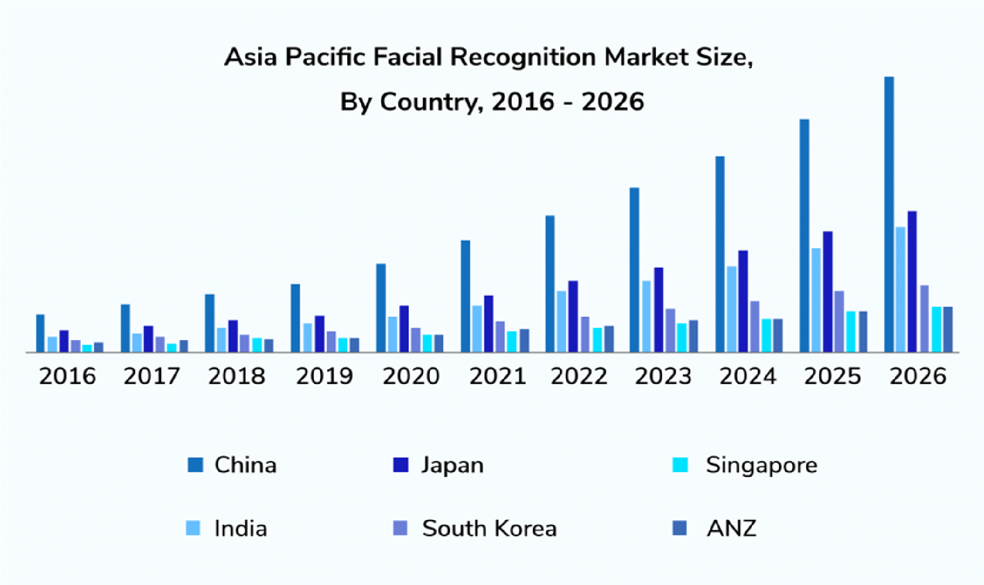

Fig 35. google : Face recognition market size

The face recognition industry has witnessed significant advancements in recent years, and its future scope is promising. Here are some potential areas of growth and development in the face recognition industry:

**Enhanced Accuracy and Performance**: Future advancements will focus on improving the accuracy and performance of face recognition systems. This includes refining algorithms, leveraging deep learning techniques, and integrating multiple modalities like 3D face recognition or multispectral imaging for more robust and accurate identification.

**Real-Time and On-Device Processing**: There is a growing demand for real-time face recognition applications that can perform on-device processing without relying heavily on cloud-based servers. Future developments will aim to optimize algorithms and hardware to enable faster and more efficient face recognition on edge devices such as smartphones, surveillance cameras, and IoT devices.

**Increased Integration in Industrie**s: Face recognition technology is being increasingly adopted across various industries such as security, law enforcement, retail, healthcare, and banking. In the future, we can expect wider integration of face recognition systems in these sectors to enhance security, improve customer experience, enable personalized services, and streamline operations.

**Facial Emotion Recognition**: Advancements in facial emotion recognition technology will enable systems to accurately detect and analyze human emotions based on facial expressions. This has applications in areas such as market research, customer experience analysis, mental health assessment, and human-computer interaction.

**Privacy and Ethical Considerations**: As face recognition technology becomes more prevalent, there will be an increased focus on addressing privacy concerns and ensuring ethical use of the technology. Future developments will involve implementing stronger privacy safeguards, obtaining informed consent, and establishing regulatory frameworks to protect individuals' rights and mitigate potential risks.

**Multimodal Biometrics:** Integration of face recognition with other biometric modalities, such as fingerprint, iris, or voice recognition, will enhance the overall accuracy and security of authentication systems. Multimodal biometrics will enable more robust and reliable

identification processes, especially in high-security applications

**Facial Recognition in Surveillance:** The use of facial recognition in surveillance and security systems will continue to grow. Future developments will involve integrating face recognition with advanced video analytics, enabling real-time monitoring, threat detection, and forensic

analysis.

**Augmented Reality and Virtual Reality**: Face recognition technology can play a significant role in augmented reality (AR) and virtual reality (VR) applications by enabling user authentication, personalized experiences, and social interaction within immersive environments. Future developments will focus on seamless integration of face recognition with AR and VR

technologies.

Overall, the face recognition industry holds immense potential for growth and innovation. As technology continues to evolve and new challenges arise, the industry will strive to enhance accuracy, optimize performance, address privacy concerns, and explore new applications across diverse sectors. The future of face recognition is likely to be characterized by increased integration, improved user experiences, and responsible deployment to create a safer and more

efficient society.

## 12. CONCLUSION

The aim of this project is to capture the video of the students, extract the faces from it, relate it with the database to ensure their presence or absence, and mark attendance to the particular student to maintain the record. The Automated Classroom Attendance System helps in increasing the accuracy and speed ultimately achieve the high-precision real-time attendance to meet the need for automatic classroom evaluation.This solution is both cost-effective and efficient when contrasted to other biometric solutions. The cost and time saved are even larger because the data acquired from the face recognition attendance system is accurate in real-time. Because the overall process is automated, human intervention is limited.

In conclusion, the implementation of a face recognition attendance system project offers numerous benefits and advancements in the realm of attendance management. The project aims to revolutionize the way attendance is recorded and tracked by leveraging cutting-edge facial recognition technology. By analyzing and identifying unique facial features, the system achieves high accuracy in individual identification, eliminating the risks associated with proxy attendance and time theft.

Furthermore, the face recognition attendance system project prioritizes efficiency and productivity. It streamlines the attendance management process, automating the recording and tracking of attendance. This reduces manual efforts, saves time, and enhances overall administrative efficiency. The system's contactless nature also promotes hygiene and safety, especially in the context of germ transmission, making it an ideal solution for various environments.

One of the project's core objectives is the seamless integration and compatibility with existing systems. By integrating with payroll or HR management software, the system ensures smooth data synchronization and facilitates comprehensive attendance reporting and analytics. These reports offer valuable insights into attendance patterns, trends, and compliance, empowering organizations to make informed decisions.

Moreover, the face recognition attendance system project aims for scalability, accommodating organizations of different sizes and handling high volumes of attendance data. It can be easily scaled and customized to meet the specific needs and requirements of diverse industries and sectors.

Overall, the successful implementation of a face recognition attendance system project revolutionizes attendance management, offering accuracy, efficiency, security, and hygiene. It marks a significant step forward in optimizing organizational processes and enhancing productivity. By leveraging state-of-the-art facial recognition technology, this project contributes to a future where attendance management becomes seamless, reliable, and user-friendly.

## 13. REFERENCES

* P. Kaur,“Transfer Learning using CNNs”.2 017 [Online] Available: <http://parneetk.github.io/blog/CNN-TransferLearning1/>
* K. Bridgeport,“Principal Component Analysis”, Kiwi.bridgeport.edu, 2018. [Online]

Available: <http://kiwi.bridgeport.edu/cpeg540/PrincipalComponentAnalysis_Tutorial.pdf>

* "Face Recognition Techniques: A Review”, International Journal of Engineering Research and Development, Vol. 4, No. 7, pp. 70-78, 2012. [Online] Available: <https://pdfs.semanticscholar.org/ba7c/01e1432bffc2fcde824d0b0ebd25ad7238c3.pdf>
* Jiang, E. (2020, July). A review of the comparative studies on traditional and intelligent face recognition methods. In 2020 International Conference on Computer Vision, Image and Deep Learning (CVIDL) (pp. 11-15).
* M. C. Kirana, Y. R. Putra, and F. W. Sari, “Comparison of Facial Feature Extraction on Stress and Normal Using Principal Component Analysis(PCA) Method,” Proc. 2017 5th Int. Conf. Instrumentation, Commun. Inf. Technol. Biomed. Eng. ICICI-BME 2017, no. November, pp. 100–105, 2018.
* Karnalim, Oscar, et al. "Face-face at classroom environment: Dataset and exploration." 2018 Eighth International Conference on Image Processing Theory, Tools and Applications (IPTA). IEEE, 2018
* Li, Xiang-Yu, and Zhen-Xian Lin. "Face recognition based on HOG and fast PCA algorithm." The Euro-China Conference on Intelligent Data Analysis and

Applications. Springer, Cham, 2017.

* <https://www.ijeat.org/wp-content/uploads/papers/v8i3S/C11230283S19.pdf>
* S L Suma, Sarika Raga. “Real Time Face Recognition of Human Faces by using LBPH and Viola Jones Algorithm.” International Journal of Scientific Research in Computer Science and Engineering ,Vol.6, Issue.5, pp.01- 03, Oct. 2018
* Kanti, Jyotshana, and Shubha Sharm. "Automated Attendance using Face Recognition based on PCA with Artificial Neural Network." International journal of science and research IJSR(2012).
* <https://theijes.com/papers/v4-i11/Version-2/A0411020108.pdf>
* [https://ijarcce.com/wp-content/uploads/2012/03/IJARCCE10A-a-Jyotshana-smart-attend ance.pdf](https://ijarcce.com/wp-content/uploads/2012/03/IJARCCE10A-a-Jyotshana-smart-attendance.pdf)
* [https://www.semanticscholar.org/paper/Face-Recognition-based-Lecture-Attendance-Syst em-Kawaguchi-Shoji/4b6811cd2a7a6924fed4967c2b755c0942ca5351](https://www.semanticscholar.org/paper/Face-Recognition-based-Lecture-Attendance-System-Kawaguchi-Shoji/4b6811cd2a7a6924fed4967c2b755c0942ca5351)
* [https://www.researchgate.net/publication/224166401_Using_real_time_computer_vision](https://www.researchgate.net/publication/224166401_Using_real_time_computer_vision_algorithms_in_automatic_attendance_management_systems)

[_algorithms_in_automatic_attendance_management_systems](https://www.researchgate.net/publication/224166401_Using_real_time_computer_vision_algorithms_in_automatic_attendance_management_systems)

* <https://pyimagesearch.com/2021/04/19/face-detection-with-dlib-hog-and-cnn/>
* <https://www.width.ai/post/facial-detection-and-recognition-with-dlib>
* [https://www.researchgate.net/publication/341876647_Face_Recognition_based_Attendan ce_Management_System](https://www.researchgate.net/publication/341876647_Face_Recognition_based_Attendance_Management_System)
* <https://github.com/TomSchimansky/CustomTkinter>
* <https://medium.com/mlcrunch/face-detection-using-dlib-hog-198414837945>
* <https://www.ijraset.com/research-paper/face-recognition-attendance-system>